How are the illustrations from Paul Revere and William Champney of the Boston Massacre propaganda?

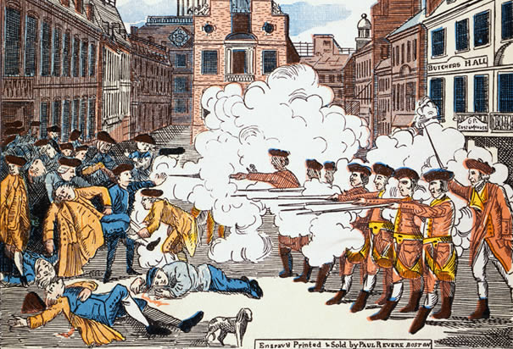
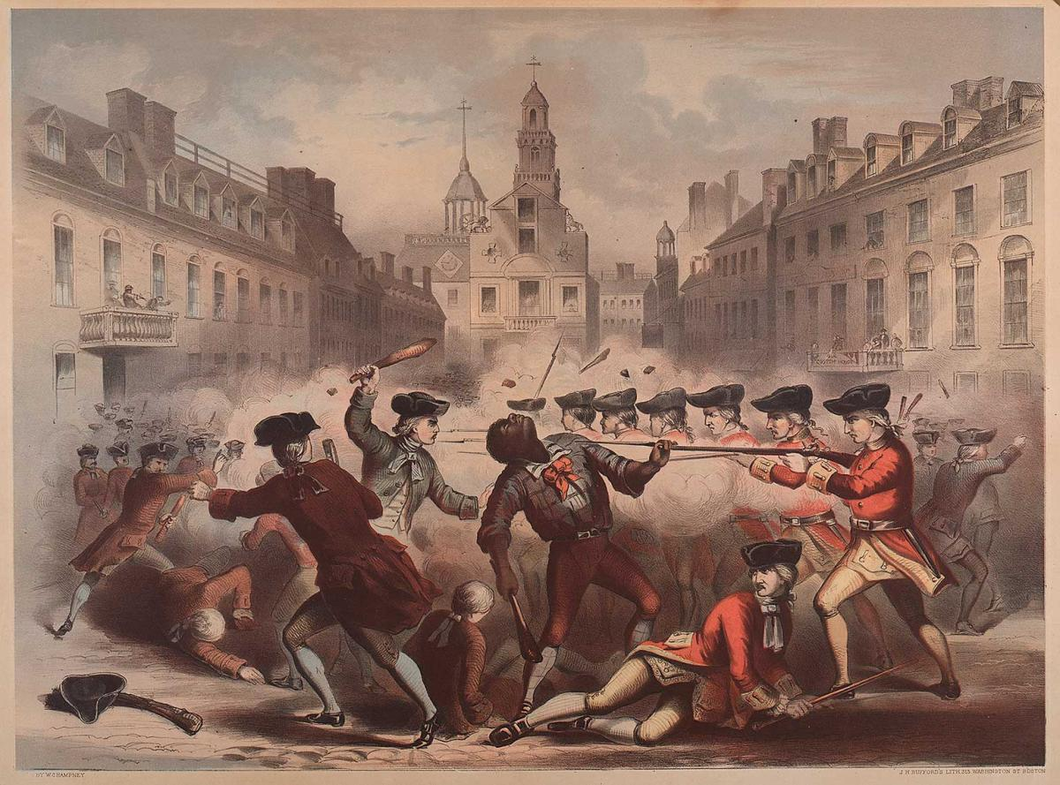

By William Champney By Paul Revere

Overview: In 1770, five colonist’s deaths sparked anger against the British government rule.

