Reading A
Daily life for a slave in North Carolina was incredibly difficult. Slaves, especially those in the field, worked from sunrise until sunset. Even small children and the elderly were not exempt from these long work hours. Slaves were generally allowed a day off on Sunday, and on infrequent holidays such as Christmas or the Fourth of July.
During their few hours of free time, most slaves performed their own personal work. The diet supplied by slaveholders was generally poor, and slaves often supplemented it by tending small plots of land or fishing. Many slave owners did not provide adequate clothing, and slave mothers often worked to clothe their families at night after long days of labor. One visitor to colonial North Carolina wrote that slaveholders rarely gave their slaves meat or fish, and that he witnessed many slaves wearing only rags. Although there were exceptions, the prevailing attitude among slave owners was to allot their slaves the bare minimum of food and clothing; anything beyond that was up to the slaves to acquire during their very limited time away from work.
Shelter provided by slave owners was also meager. Many slaves lived in small stick houses with dirt floors, not the log slave cabins often depicted in books and films. These shelters had cracks in the walls that let in cold and wind, and had only thin coverings over the windows. Again, slave owners supplied only the minimum needed for survival; they were primarily concerned with keeping their financially valuable slaves alive and working rather than providing for their comfort, health, or safety.
Slaves had no way to legally protest their masters’ harsh treatment and abuse. A black person had no means of bringing a complaint to court, and could not even testify against a white person who had committed a crime against him or her. In fact, before 1774 it was not a crime in North Carolina to assault or even kill a slave. After 1774, a white person who murdered a slave would receive only 12 months in prison if it was their first offense. However, according to the 1774 law, if the slave was killed while the white person was using “moderate correction” to punish him or her, there would be no criminal charge.
A city slave is almost a freeman, compared with a slave on the plantation," wrote the abolitionist Frederick Douglass, who escaped slavery in 1838 at the age of 20. "He is much better fed and clothed, and enjoys privileges altogether unknown to the slave on the plantation." This is not to say that city-dwelling slave owners were by nature more compassionate than plantation owners. Scholars argue that, among other factors, urban dwellers' close proximity to each other served to deter individuals from brutally mistreating human property and appearing inhumane themselves.
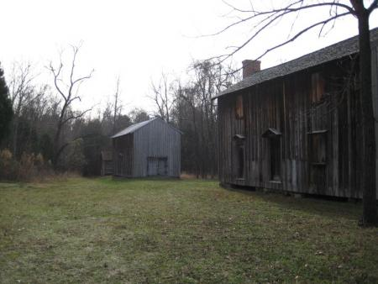
These slave quarters at Stagville Plantation would have housed as many as forty people each — and they were better quarters than most slaves had.
It’s almost impossible for us today to imagine how difficult life was for a slave in the antebellum South. Work was long and hard, food and shelter were minimal, the threat of brutal punishment.

Reading B
Daily life for a slave in North Carolina was incredibly difficult. Slaves, especially those in the field, worked from sunrise until sunset. Even small children and the elderly were not exempt from these long work hours. Slaves were generally allowed a day off on Sunday, and on infrequent holidays such as Christmas or the Fourth of July.
Many slaves lived in small stick houses with dirt floors, not the log slave cabins often depicted in books and films. These shelters had cracks in the walls that let in cold and wind, and had only thin coverings over the windows.
Slaves had no way to legally protest their masters’ harsh treatment and abuse. A black person had no means of bringing a complaint to court, and could not even testify against a white person who had committed a crime against him or her. In fact, before 1774 it was not a crime in North Carolina to assault or even kill a slave.
During their few hours of free time, most slaves performed their own personal work. The diet supplied by slaveholders was generally poor, and slaves often supplemented it by tending small plots of land or fishing. Many slave owners did not provide adequate clothing, and slave mothers often worked to clothe their families at night after long days of labor.

These slave quarters at Stagville Plantation would have housed as many as forty people each — and they were better quarters than most slaves had.
It’s almost impossible for us today to imagine how difficult life was for a slave in the antebellum South. Work was long and hard, food and shelter were minimal, the threat of brutal punishment always was around, and families could be broken up at a master’s whim. Yet, heroically, enslaved people made lives for themselves — families, religion, a culture, even art.

Reading C
Daily life for a slave in North Carolina was incredibly difficult. Slaves, especially those in the field, worked from sunrise until sunset. Even small children and the elderly were not exempt from these long work hours. Slaves were generally allowed a day off on Sunday, and on infrequent holidays such as Christmas or the Fourth of July.
Many slaves lived in small stick houses with dirt floors, not the log slave cabins often depicted in books and films. These shelters had cracks in the walls that let in cold and wind, and had only thin coverings over the windows.
Slaves had no way to legally protest their masters’ harsh treatment and abuse. A black person had no means of bringing a complaint to court, and could not even testify against a white person who had committed a crime against him or her.

These slave quarters at Stagville Plantation would have housed as many as forty people each — and they were better quarters than most slaves had.
It’s almost impossible for us today to imagine how difficult life was for a slave in the antebellum South. Work was long and hard, food and shelter were minimal, the threat of brutal punishment always was around, and families could be broken up at a master’s whim. Yet, heroically, enslaved people made lives for themselves — families, religion, a culture, even art.

